**Jordan University of Science and Technology**

**Faculty of Computer and Information Technology**

**Department of Computer Engineering**



**CPE 592: Graduation Project Final Report**

**[Medical ChatBot]**

**Student 1 Bahaa Hayajneh**

**Student 2 Omar Ababneh**

**Student 3 Shomo’a AlHalabi**

**Student 4 Mohammad Betamony**

**Supervised By: Dr. Khaldon Muhaidat**



1. **Abstract**

A medical chatbot is an AI-powered chatbot designed to diagnose diseases. It is mainly used to predict the disease based on the patient's symptoms.  
Diseases that our chatbot can predict drug reaction, Malaria, Allergy, Hypothyroidism, Psoriasis, GERD, Chronic, cholestasis, hepatitis A, Osteoarthritis, (vertigo) Paranasal Positional Vertigo, Hypoglycemia, Acne, Diabetes , Impetigo  
Hypertension Peptic ulcer disease Dimorphic hemorrhoids  (piles), Common Cold Chicken Pox, Cervical spondylosis Hyperthyroidism Urinary tract infection Varicose veins AIDS  
Paralysis (brain hemorrhage) Typhoid Hepatitis B, Fungal infection, Hepatitis C, Migraine, Bronchial Asthma, Alcoholic, hepatitis, Jaundice, Hepatitis E, Dengue, Hepatitis D, Heart attack, Pneumonia, Arthritis, Gastroenteritis, Tuberculosis  
Covid-19  
When the patient writes down their symptoms and then submits them, the chatbot renders a response that includes the disease the patient may have.  
E-Health Jordan aims to raise awareness of the medical field by using AI to provide the population with a brief diagnosis of a possible disease, including the name of the disease and its description, as well as small precautions for recovery, such as going to the nearest hospital, eating a balanced diet, getting enough sleep, exercising, and seeing a doctor  
In recent days, we have seen what the coronavirus has done in the world, especially in our country, Jordan, which has led to a great rush in hospitals, which has also led to an increase in the number of infections due to the contagion of patients. Particularly in the case of some diseases that are similar in symptoms to other diseases, there may be conflict between patients as to which disease it is, e.g., influenza, Allergy, common cold, or covid-19.  
This diagnoses by chatbot does not mean refraining from consulting the doctor, but that you should cooperate with him, so it is best to consult a doctor for a specific diagnosis and treatment plan. If the symptoms are severe, it may be necessary to go to the hospital for further treatment.

1. **Introduction**

The health sector is a source of pride and one of the most important resources for Jordan, but the lack of effective referral systems and the unequal distribution of medical investment, resources, and talent between rural and urban areas in Jordan mean that patients to crowd into larger hospitals, and many patients are even forced to wait in line for long periods of time.

Since thousands of patients do not have the opportunity to visit a faraway hospital, or they do not have time, or they are too lazy, so we understand that we need to create a medical chatbot, especially nowadays Covid-19 has had a profound impact on the medical sector. The pandemic has forced hospitals to change the way they operate and place more emphasis on preventive. Through medical chatbot you can get the best diagnosis for your condition without visiting a hospital, saving time, effort, and money.

The need for remote access or virtual consultations is the need of the hour, which needs to be taken care of to stay one step ahead in the technology adoption rate.

Technology will play an increasingly important role as a safeguard against errors that could have a serious negative impact on patient outcomes.

However, as with any computerized system, there is always the possibility of error. Some estimates suggest that chatbots are correct up to 80% of the time, and that percentage is very good, but it will depend on dataset size and training and validation data.

The introduction of telehealth and virtual or electronic visits will reduce hospital-acquired conditions, post-operative infections, and other complications.

The chatbot needs to rely on machine learning, and the more users engage with it by submitting their symptoms, the smarter it becomes. Thus, every further conversation becomes more effective to get the best diagnosis, relevant information provides a better user experience. It also increases online credibility.

A chatbot must have artificial intelligence to do more than simple disease diagnoses. AI enables bots to learn from the symptoms they receive from end users. Behind all this learning is analytics platforms, integration with OpenAI API. These add to AI and provide resources for the chatbot to properly diagnose patients.

some common technologies and algorithms used in medical chatbots include natural language processing (NLP) and machine learning (ML) including:

• Semantic Parsing:

It converts the patient's symptoms into a form that the computer can understand.

• Automated planning:

It selects a set of actions to achieve a goal to get correct diagnosis

• Natural language generation:

It helps the computer respond to people in their own language.

-The chatbot can also give you effective disease description and correct health advice.

Most of us who need medical advice are more likely to ask our friends and family members on social media, which does more harm than good as it leads to the spread of incorrect information.

There are many potential benefits of medical chatbots for disease diagnosis. For example, chatbots could potentially help speed up the diagnostic process. In addition, chatbots could help reduce healthcare costs by automating simple tasks such as describing a patient's illness or the proper precautions for recovery. With a chatbot, you can be sure that you will get the best diagnosis and a correct description of your disease, as well as effective precautions.

1. **Professional Practice Constraints**

Manufacturability Constraints; Medical chatbots must be ready to accurately diagnose diseases in order to be useful. However, thanks to the complexity of the human body and the multitude of diseases that exist, this is often difficult to achieve. Manufacturability constraints can make it even harder, as chatbots might not be able to accurately replicate the manufacturing process of a disease. this will lead to incorrect diagnoses and potentially dangerous treatments.

especially when user miswrites the symptoms or misinterpretation what the patients feel therefore the chatbot must be clever enough to try to understand all misspellings words and detect them correctly

**Economic Constraints:**

There are a variety of economic constraints that may limit the effectiveness of medical chatbots in diagnosing disease. First, the value of developing and maintaining a chatbot may be prohibitive for many organizations, especially smaller ones. Second, chatbots might not be able to accurately diagnose all diseases, and a few diseases may be more difficult to diagnose than others. Third, chatbots might not be able to keep up with the latest medical research and developments, and as a result, their diagnoses could also be outdated or inaccurate.

1. Financial Constraints

2. Limited allow developing and deploying chatbots

3. Lack of coverage for chatbot-based diagnosis and treatment

4. Temporal Constraints

5. Time required to develop train and deploy chatbots

6. Length of time required for chatbots to be effective in diagnosis and treatment.

**Sustainability:**

There are some key sustainability constraints that we considered when building a medical chatbot to help identify diseases. First, the chatbot must be designed to be updated frequently with the most recent medical knowledge to maintain its accuracy. Second, the chatbot’s data sources must be reliable and unbiased to ensure that the information it provides is trustworthy. Finally, the chatbot must be designed to be accessible to as many of us as possible, no matter their location or ability to pay it must be free to get large experiences from all patients to improve chatbot training to get correct diagnosis.

**Environmental Constraints:**

There are a variety of environmental constraints that can impact the ability of medical chatbots to accurately diagnose disease. These include the standard of the data used to train the chatbot, the quantity of data available, the number of medical experts involved in the development of the chatbot, and therefore the chatbot's ability to access symptoms records.

Health IT can lessen environmental impacts by reducing the necessity to use transportation and by reducing

the amount of paper used in medical records.

**Health and Safety Constraints.**

1. All medical chatbots must adhere to strict health and safety standards and be credible to ensure accuracy and prevent injury or illness.

2. all medical chatbots must be tested and certified by professionals before they can be used.

3. only certified medical chatbots can be used to diagnose diseases.

4. all medical chatbots must be updated regularly to ensure their accuracy.

5. users of medical chatbots must be trained on how to use them properly and what diseases they can diagnose.

6. the chatbot should not be used to diagnose serious or life-threatening diseases.

7. the chatbot should not be used as a substitute for a professional medical consultation.

8. the chatbot should not be used to promote self-diagnosis or self-treatment.

**Political Constraints:**

There may be policy restrictions on medical chatbots that prevent them from making an accurate disease diagnosis. For example, a chatbot may be designed to avoid mentioning certain diseases that are considered politically sensitive, such as HIV/AIDS or cancer, because these diseases require medical tests and specialized equipment to correctly identify them. This could result in the chatbot providing inaccurate or incomplete information about these diseases, which in turn could lead to misdiagnosis or delayed treatment.

**Ethical Standards Constraints:**

We put no restrictions on chatbot, allowing it to respond to all patients regardless of their race or religion, respond to all audiences in society to improve response generated by patient symptoms in any society

Since health is a sensitive and important issue, Chatbot will not rather than your doctor and Chatbot will in some cases advise you to visit a hospital for further medical care to increase reliability

**Social Values Constraints:**

There is a possibility that medical chatbots may be biased in diagnosing disease if they are not programmed to take social constraints into account. For example, a chatbot may be more likely to diagnose a disease in a person it does not have, or the symptoms are not programmed into our dataset, so the chatbot needs to be specific about what the disease is.

The user needs to be aware that the chatbot may not recognize some symptoms or select the disease incorrectly because the chatbot is well-trained in a particular disease dataset or poorly trained in other diseases.

1. **[System Architecture and Design](C:\\Users\\C:\\Users\\user\\Downloads\\Capstone_project2_template (3).doc" \l "page8)**

**OpenAi**

The OpenAI API is used to solve tasks that involve a natural language processing problem, a classification problem and others. Therefore, we chose this API to solve our problem:  
- Content generation  
- Summarisation  
- Classification, categorisation and sentiment analysis  
- Extraction of data  
- Translation  
- Many more!  
Prompts and completions the prompt is the input, and the completion is the output and the core of OpenAi the models understand and process text by breaking it down into tokens the tokens can be words or just parts of characters. OpenAI provides models that are trained to understand and generate text. It also provides clients with the ability to create a custom model to solve their problem.  
To make sense of a model, we need to define some instructions and variables.  
The API is very intelligent. If you ask it a question, it can answer it, but if you need a more precise answer, there are some variables and instructions that help you get more precise answers. So, if you add some examples to the API, it will be able to learn and understand what you want from it.

Some of the variables we can change are found directly below [1].

# **Temperature:**

# Temperature is a value between 0 and 1. 0 means that if you ask it the same question more than once, the model will return the same or a very similar answer, but if we increase the temperature and ask the same question more than once, there will be different answers. In other words, a lower temperature means that the model takes fewer risks and that the results are more accurate and deterministic. Increasing the temperature leads to more varied results. In our model, we lowered the temperature because the problem is very sensitive, so the model will be accurate and take fewer risks.

**Max Length:**

Maximum number of tokens that generate the completion answer, 1 token is almost 4 characters, the best choice is to be bigger than 256 tokens, because if it is small the completion will not be complete.

**Stop sequences:**

This variable is used to tell the api model where to stop generating more tokens.‏

# **Completion:**

The completion endpoint is the best practice for generating completion for any text as a prompt by giving the context or pattern, the completion context you see differ from the same prompt, if the temperature variable is high, the best choice is to decrease this variable to give the completion answer close to context.

### Prompt design:

1. Classification: if you want to classify the completion answer as positive or negative, you can use a classification model to give the answer.
2. Conversation: by talking to people, for example, to give them tips to solve a certain problem, or to act as a robot to provide accurate service to customers.
3. transformation: by translating the prompt from one language to a specific language, or by transforming this text into different forms and expressions.
4. editing the prompt: by giving it a prompt with grammatical errors and then correcting it to give it a correct meaning.

# **Davinci and GPT-3**

We chose Davinci because it is the most powerful and can do everything any other model can do, and much more - often with fewer instructions.[2]  
GPT-3 is one of the largest and best-known neural networks for natural language applications on the market. With 175 billion parameters, it far outperforms similar models.  
The GPT-3 (Generative Pre-trained Transformer 3) architecture consists of two main components: an encoder and a decoder. The encoder takes as input the previous work in the sentence and generates a vector representation of it, which is then passed through the attention mechanism to generate the next word prediction. The decoder takes as input both the previous word and its vector representation, and outputs a probability distribution over all possible words given that input.   
We used GPT-3 models in our case because GPT-3 is a set of models that can understand and generate natural language. Another reason for using GPT-3 is that we received a recommendation from chatbot experts.  
The main reason for using GPT-3 is that the model is so general that users can use GPT-3 in any case, including mobile app creation, search engine development, language translation and poetry writing. The model includes more than ten times as many parameters as the next largest NLP model, Microsoft's Turing-NLG, so the accuracy of GPT-3 and the value it can deliver are significantly higher.

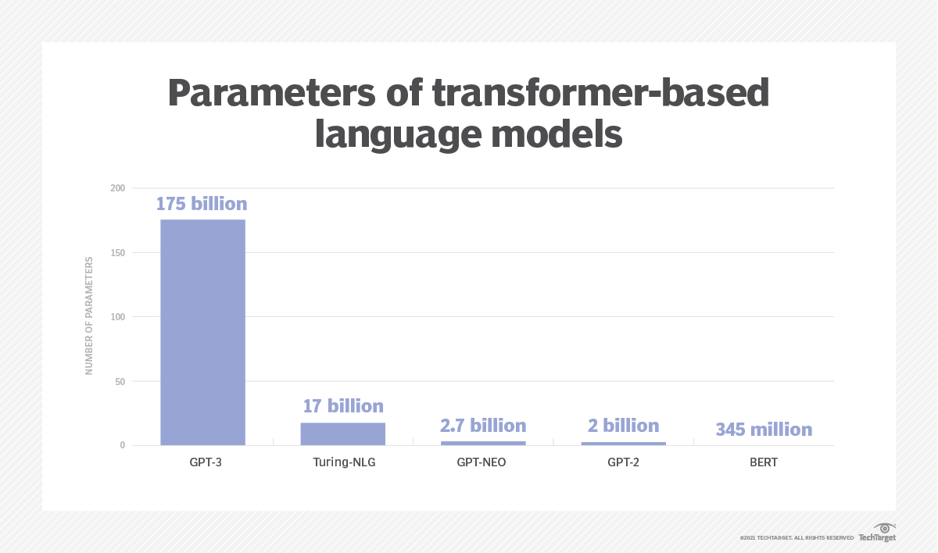

Figure 1

"The AI industry is excited about GPT-3 because its 175 billion parameter-weighted connections provide tremendous flexibility for developing NLP applications," said Dattaraj Rao, senior data scientist at Persistent Systems.  
The OpenAI AI research lab that developed GPT-3 trained the model with more than 45 terabytes of data from the internet and books to support 175 billion parameters. [3]  
"The criteria in the machine language represent the capabilities or knowledge of the model. So, the more parameters there are, the better the model is," Shukla said.  
Parameters are like variables in an equation. In a simple mathematical equation like "a + 5b = y", "a" and "b" are parameters and "y" is the result. In a machine learning algorithm, these parameters correspond to the weighting between words, such as the association between their meaning or common usage. [3]  
Developers can use OpenAI in any language, e.g. Python, JavaScript, Java, Rust, etc.

**How GPT-3 Actually Works, From the Ground Up?**

Below is GPT-3's response after being asked to imitate a psychologist:

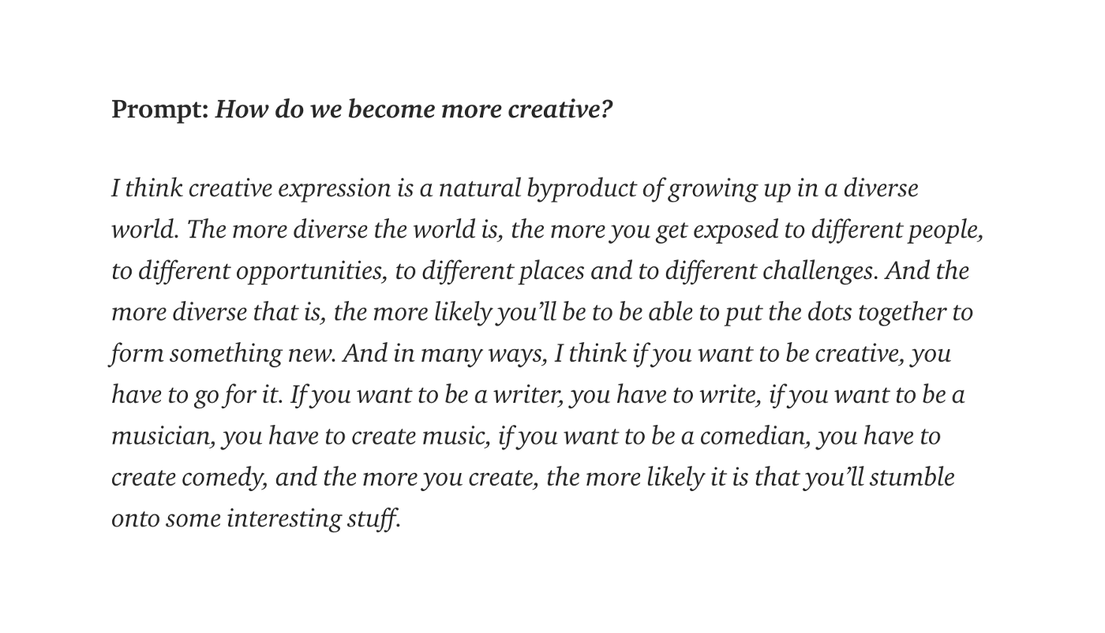

Figure 2

How does it work? It is a robot that can do practically anything you ask of it.  
To answer this question, you should look at the field of NLP as a whole, also understand OpenAI's specific GPT techniques, and then how they train GPT What is NLP?  
Natural Language Processing (NLP) is concerned with programming computers to analyse and produce text that is readable by humans.  
The language model is a type of machine learning model that analyses written text. An example of a language model is predictive text on a mobile phone that suggests the next word as you type. This is very close to a basic concept for GPT-3.  
The prediction of new words in the language model depends on analysing the written text and calculating the probability of the expected words, then predicting the highest probability.  
GPT-3 uses a special language model that is divided into two parts: the encoder, which converts the text sequence into a number vector that can be easily understood by a computer, and the decoder, which decodes the information and outputs the sequence.  
In each iteration of the encoder, each word is assigned a numerical weight, which is then analysed by the decoder. In this way, the key aspects of the input text on which the output is to be based are determined.  
The encoding and decoding components are stacked as follows:

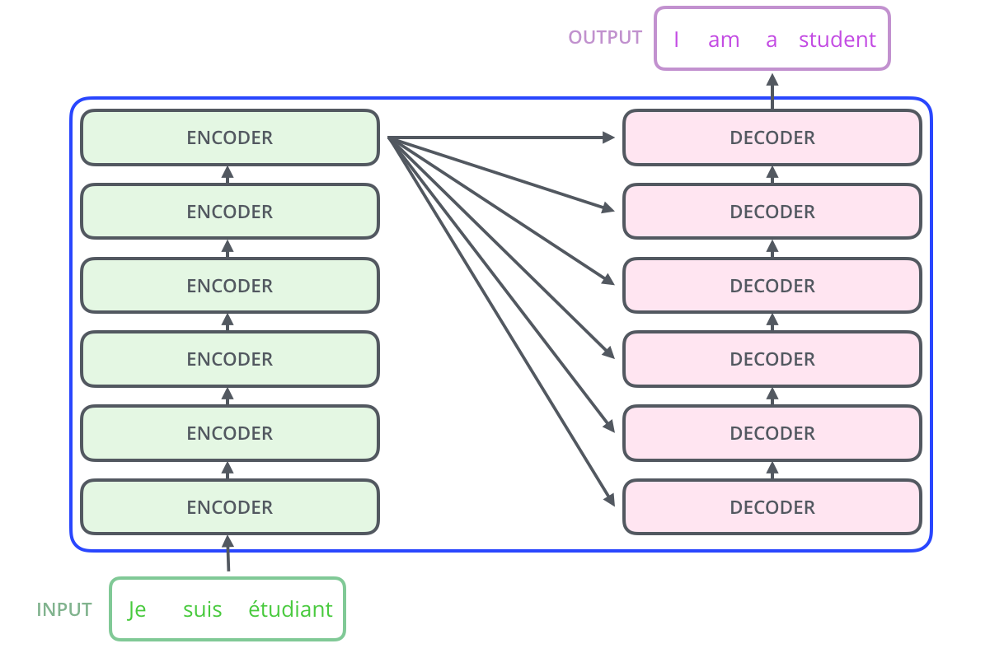

Figure 3

The encoder consists of two main parts:

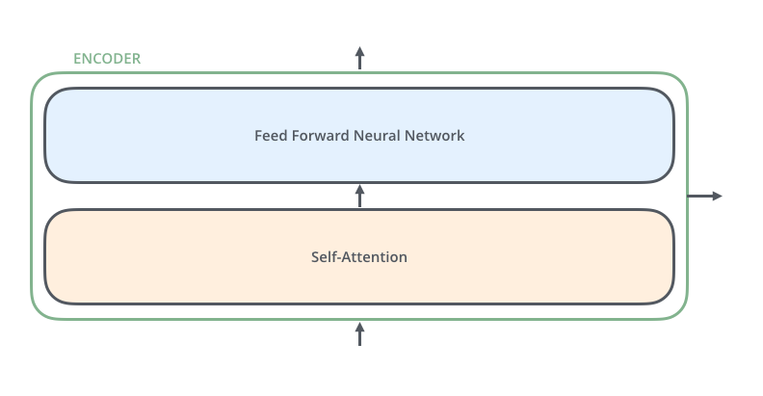

Figure 4

In the decoder, however, the same contains another layer, the attention layer, which helps the decoder to focus on relevant parts of the input sentence

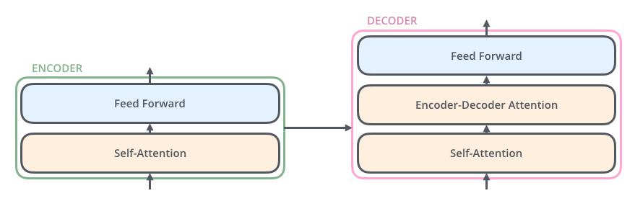

Figure 5

The model converts each word into a vector using an embedding algorithm.  
The basic idea of Word Embedding is to convert text into numbers. Word Embedding aims to create a vector representation with a much lower dimensional space. These are called word vectors. [4]  
After implementing the embedding algorithm in the text, it is converted into a number vector as follows:

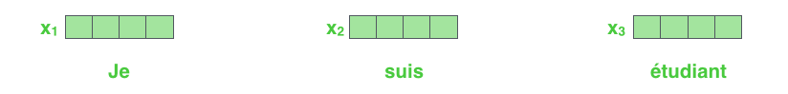

Figure 6

**Self-Attention in Detail**

The first step in calculating subjective attention is to create three vectors from each of the encoder's input vectors (in this case, include each word). So, we create a query vector, a main vector, and a value vector for each word. These vectors are generated by multiplying the modulation by three matrices that we trained during the training process.

Note that these new vectors have a dimension less than the embed vector. Its dimensions are 64, while the input / output vectors for embedding and coding have dimensions of 512. They are not smaller than them. This is an architectural decision to keep the (mostly) multi-headed interest computation constant.

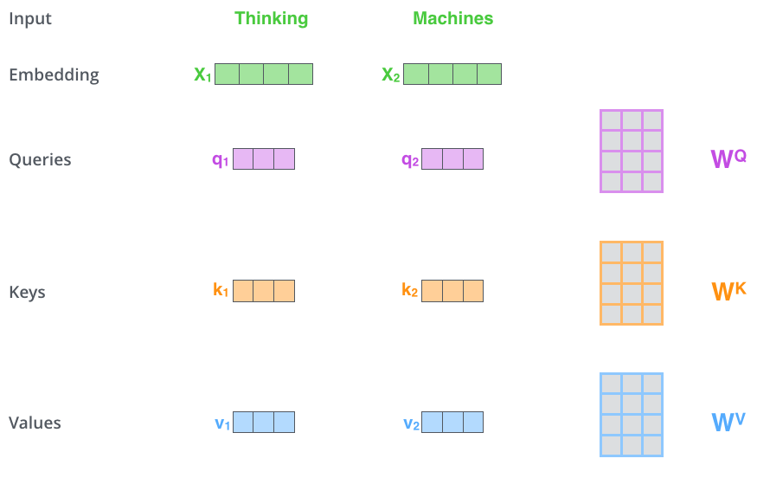

Figure 7

The second step in calculating self-interest is calculating the score. Suppose we compute subjective attention to the first word in this example, 'think'. We need to score each word in the entered sentence against that word. The score determines how much we focus on the other parts of the input sentence when we encode a word in a particular position. The result is calculated by taking the dot product of the query vector using the main vector of the given word we are logging. So, if we process the subjective attention of the word in position 1, the first order will be the dot product of q1 and k1. The second degree will be the dot product of q1 and k2.

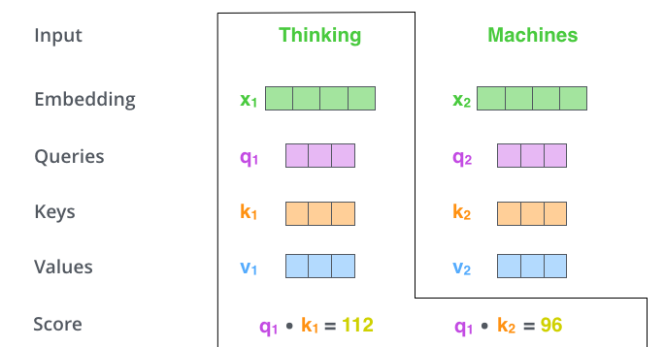

Figure 8

The third and fourth steps are to divide the scores by 8 (the square root of the dimension of the key vectors used in the work - 64. This leads to more stable gradients. Other values are possible, but this is the default), then the result is passed through a softmax operation. Softmax normalizes the scores so that they are all positive and add up to 1.

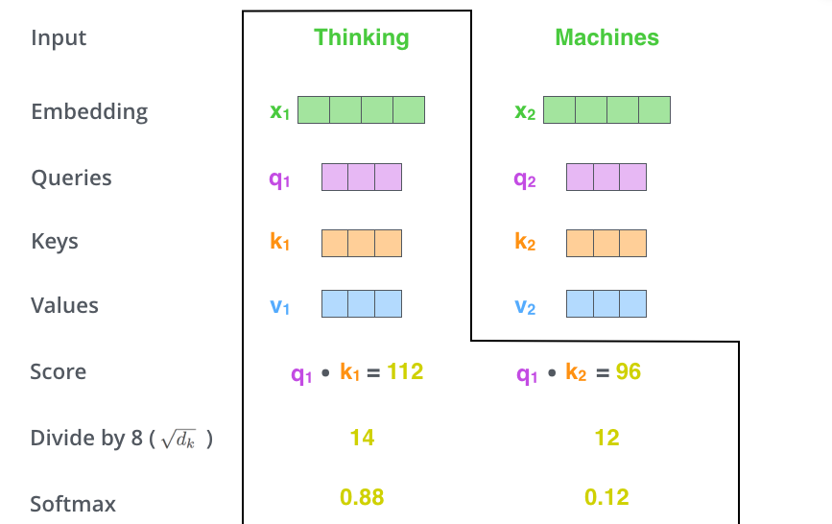

Figure 9

**Representation of the order of the sequence by position coding.:**

What is still missing in the model as we have described it so far is a way to take into account the order of the words in the input sequence.

To achieve this, the transformer adds a vector to each embedding of the input. These vectors follow a certain pattern that the model learns and that helps it determine the position of each word or the distance between different words in the sequence. The intuition behind this is that adding these values to the embeddings provides meaningful distances between the embedding vectors once they are projected into Q/K/V vectors and during dot-product attention.

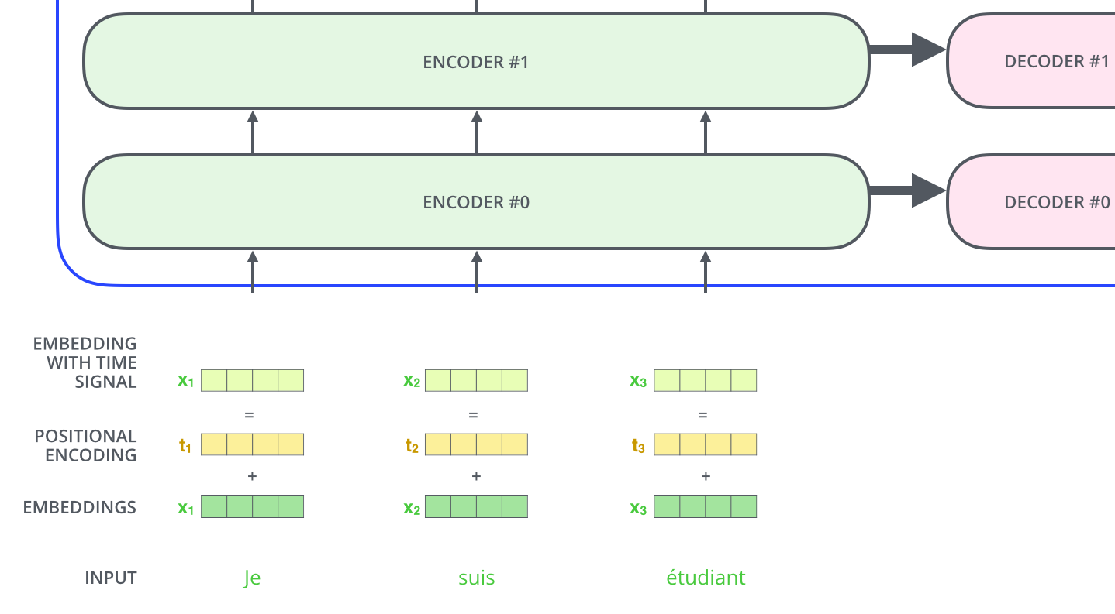

Figure 10

if we assume that the embedding has a dimensionality of 4, the actual positional encodings would be as follows:

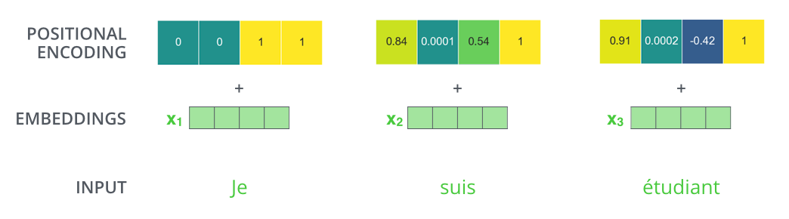

Figure 11

The encoder begins processing the input sequence. The output of the top encoder is then converted into a series of attention vectors K and V. These are used by each decoder in its 'encoder-decoder attention' layer, which helps the **decoder to focus on appropriate places in the input sequence:**

The following steps repeat the process until a special symbol is reached indicating that the transformer decoder has completed its output. The output of each step is passed to the lowest decoder in the next time step, and the decoders blow up their decoding results in the same way as the encoders. And just like with the encoder inputs, we embed and add position coding to these decoder inputs to indicate the position of each word.

**The self-awareness layers in the decoder function in a slightly different way than those in the encoder:**

In the decoder, the self-attention layer is only allowed to pay attention to previous positions in the output sequence. This is done by masking future positions (by setting them to -inf) before the softmax step in the self-attention calculation.

The "encoder-decoder attention" layer works in the same way as the multi-headed self-attention layer, except that it creates its queries matrix from the underlying layer and takes the keys and values matrix from the output of the encoder stack.

**The final linear and softmax layer:**

The decoder stack outputs a vector of floats. How do we turn this into a word? That is the task of the last linear layer, which is followed by a softmax layer.

The linear layer is a simple, fully connected neural network that projects the vector produced by the decoder stack into a much, much larger vector called the logits vector.

Let us assume that our model knows 10,000 unique English words (the "output vocabulary" of our model) that it has learned from its training dataset. Then the logits vector would be 10,000 cells wide - each cell corresponding to the value of a unique word. This is how we interpret the output of the model, followed by the linear layer.

The softmax layer then converts these scores into probabilities (all positive, all adding up to 1.0). The cell with the highest probability is selected and the associated word is generated as the output for that time step. [4]

Recurrent Neural Networks (RNN) And Long/Short Term Memory (LSTM)

**RNN** and **LSTM** have established themselves as state-of-the-art approaches in sequence modelling and transcription problems such as language modelling and machine translation. Since then, numerous efforts have been made to push the boundaries of recurrent language models and encoder-decoder architectures further.

RNN

The recurrent neural network is a generalization of the feed forward neural network, which has an internal memory. An RNN is recurrent in nature as it performs the same function for each data input, while the output of the current input depends on the previous computation. After the output is generated, it is copied and sent back to the recurrent network. To make a decision, it considers the current input and the output it learned from the previous input.

RNNs can use their internal state (memory) to process sequences of inputs. This makes them suitable for tasks such as unsegmented connected handwriting recognition or speech recognition. In other neural networks, all inputs are independent of each other. But in RNN, all inputs are connected.[5]

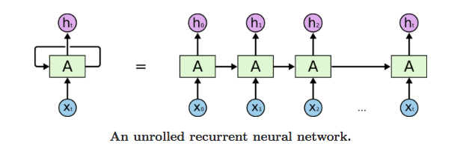

Figure 12

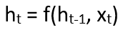

Figure 13

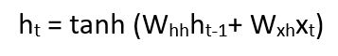

Figure 14

W = weight, h = single hidden vector, Whh = weight at previous hidden, stateWhx= weight at current input state, and tanh the *Activation function,*that implements a Non-linearity that squashes the activations to the range[-1.1].

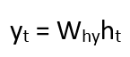

Figure 15

**Yt** is the *output state*. **Why** is the *weight at the output state.*

LSTM

Long Short-Term Memory (LSTM) networks are a modified version of recurrent neural networks that make it easier to remember past data. The problem of the vanishing gradient with RNN is solved here. The LSTM is well suited for classifying, processing and predicting time series of unknown duration. It trains the model using backpropagation. There are three gates in an LSTM network:

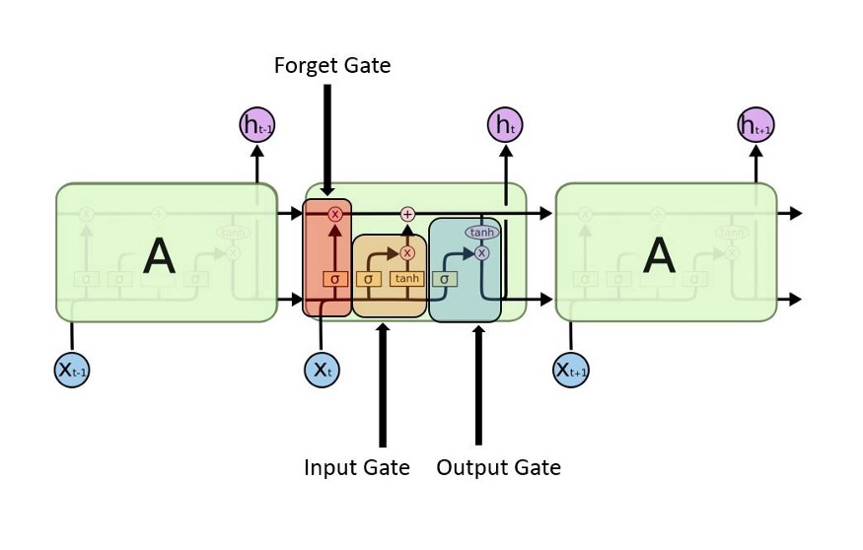

Figure 16

1. **Input gate** — discover which value from input should be used to modify the memory.

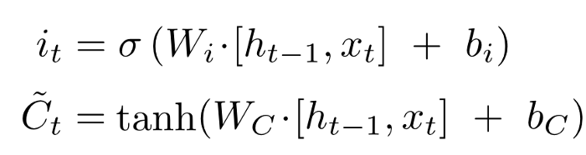

Figure 17

An activation function in a neural network defines how the weighted sum of the input is converted into an output from one or more nodes in a layer of the network.

2. **forget gate** - discover which details to discard from the block. This is decided by the sigmoid function. It looks at the previous state (ht-1) and the content input (Xt) and outputs a number between 0 (omit) and 1 (keep) for each number in the cell state Ct-1.

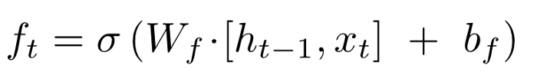

Figure 18

**3. Output gate** the input and the block's memory are used to determine the output. The sigmoid function decides which values to pass through 0, 1 and tanh weights the past values according to their importance between -1 and 1 and multiplies them by the output of sigmoid.

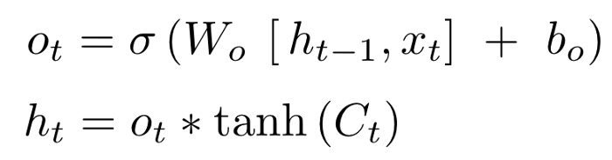

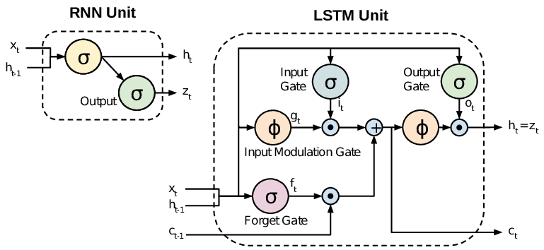

Figure 19

Attention decides what to shop before even calculating a probability. In this way, the algorithm can prioritize which parts of the text it pays attention to. Below is a diagram of the architecture of a transformer, Figure 8 [9].

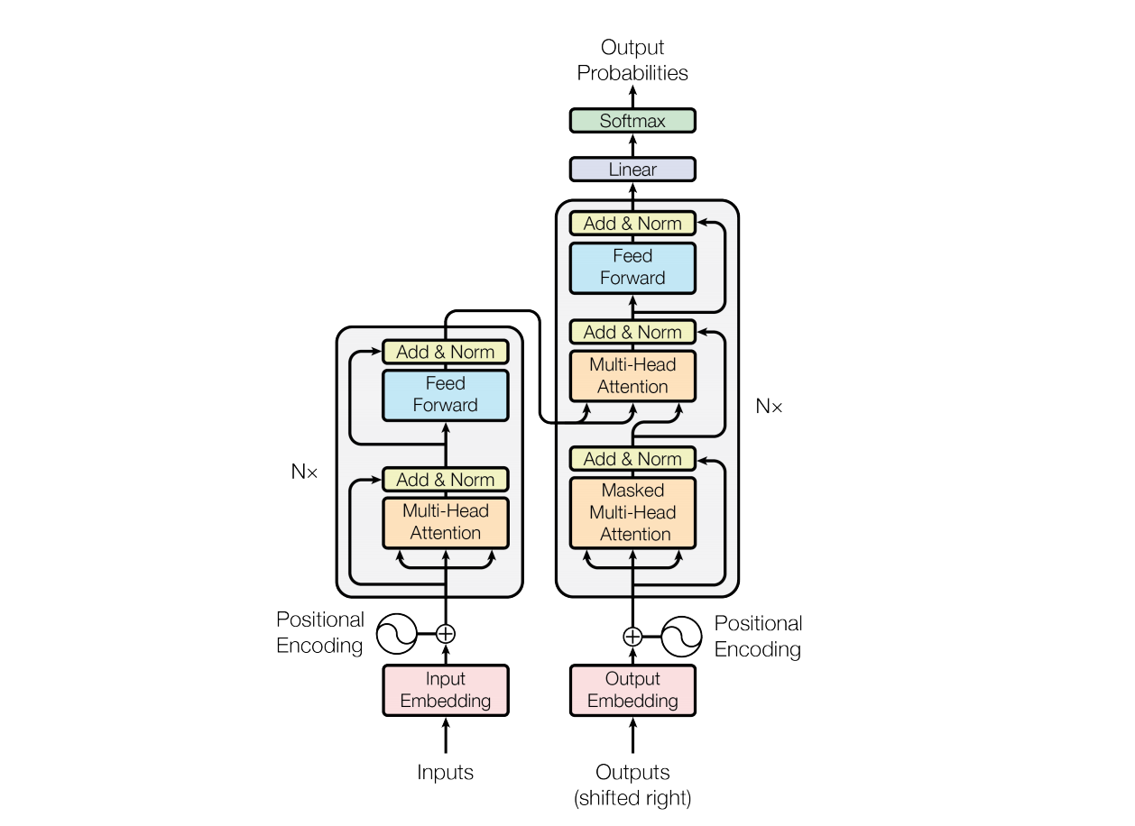

Figure 20

Another advantage of transformers is that they can analyze several parts of a text simultaneously.

In other words, the whole algorithm does not have to be run every time you want to generate a new word in a sequence - it can input and output large paragraphs at once, which not only improves the algorithm's "attention span" but also significantly reduces the time it takes to compute.[6]

**Training The Data by OpenAi Api**

Training Model is one of the most important processes, because the algorithm is the machine of boxes that are related with each other, then the model must be taught how the process given input, to learn process the context of the appropriate word , this process is called ‘next word prediction ‘ to predict next word of sequence,



Figure 21

The parameter before training has a random variable, then the training model gives the appropriate value to each parameter, the process generated by passing some text as input, and the output generated by the learning period.



Figure 22

This process above can be generated by ‘next predict word’, giving some text as input, and generated output by predicting the next word by repeating millions of times and calculating error prediction and updating the next word to generate the better prediction



Figure 23

**Word Embeddings**

The Big Idea of Word Embedding is to show any textual content into numbers. So, a solution to “What’s word embedding?” is it’s a method of creating a low- dimensional vector representation from corpus of the textual content, which preserves the contextual similarity of phrases, every phrase has a related vector.[7]

So, a natural language modelling method like Word Embedding is used to layout phrases or expressions from a vocabulary to a corresponding vector of actual numbers. As properly as being amenable to processing with the aid of using mastering algorithms, this vector has important and profitable properties

* Dimensionality Reduction — it is an extra powerful illustration
* Contextual Similarity — it is an extra suggestive illustration

Word Vectors are used for semantic parsing, to extract which means from textual content to permit natural language understanding. For a language model to be appropriate to are expecting the which means of text, it desires to be apprehensive of the contextual similarity of phrases. For case, that we tend to discover fruit words (like apple or orange) in rulings wherein they’re grown, picked, eaten and juiced, however might not expect to find the ones identical conceptions in comparable near propinquity to, say, the phrase airplane. The vectors created through Word Embedding keep those similarities, so phrases that often be close by in text can also be in near proximity in vector area in word2vec, a disbursed representation of a word is used. Take a vector with numerous hundred confines (say 1000). Each word is represented through a distribution of weights throughout the one’s essentials. So as a substitute of a one- to- one mapping among a detail in the vector and a word, the representation of a phrase is unfolded throughout all the elements withinside the vector, and every detail withinside the vector contributes to the outline of several phrases. We locate that the discovered phrase representations seize significant syntactic and semantic regularities in a usually easy way. Specifically, the regularities are discovered as constant vector equipoises among dyads of phrases taking part a selected relationship. For case, if we denote the vector for phrase i as xi, and focus on the singular/ plural relation, we have a look at that xapple – xapples ≈ xcar – xcars, xfamily – xfamilies ≈ xcar – xcars, and so on. perhaps extra unexpectedly, we find that that is additionally the case for loads of semantic relations, as measured through the SemEval 2012 mission of measuring relation similarity. Introducing Word2Vec Now we recognize what it is, how does it work? If you’ve encountered dimensionality discount earlier than you’ll recognize that is normally performed the usage of an unsupervised learning algorithm. And that is the method utilized by one of the best recognized algorithms for generating phrase embeddings word2vec. There are methods to use word2vec, CBOW (Continuous Bag- Of- Words) and Skip- gram. In CBOW we`ve a window round a few targets phrase and additionally consider the phrases round it (its environment). We deliver the ones phrases as enter our community and additionally use it to try and are expecting the goal phrase. Skip- gram does the contrary, you've got a goal phrase, and you try and are expecting the words which are in the window around that word, i.e., are expecting the context round a word. [8]

The input words are handed in as one-hot encoded vectors. This will move right into a retired layer of linear units, additionally right into a softmax subcase to make a prediction. The concept then to teach the hidden layer weight matrix to locate powerful representations for our words. This weight matrix is normally known as the embedding matrix and may be queried as a look- up table.[9]

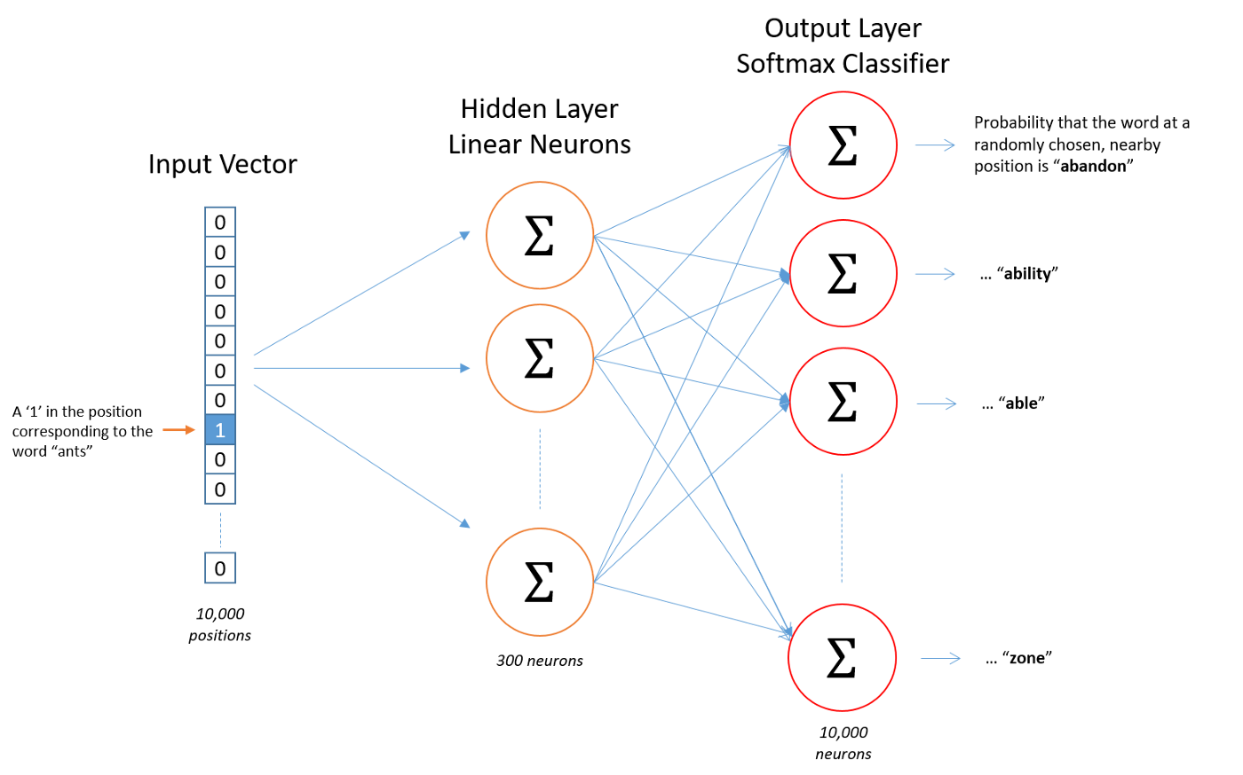

Figure 24

The embedding matrix has a size of the number of phrases through the number of neurons in the hidden layer (the embed size)[3]. So, when you have phrases and three hundred hidden units, the matrix could have length × three hundred (as we’re the usage of one-hot decoded vectors for our inputs). Once calculated, getting the word vector is a fast O (1) research of corresponding row of the matrix outcomes:

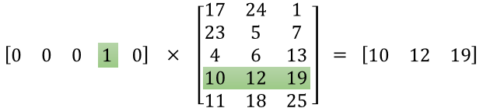

Figure 25

**Where does deep learning come in?**

Keep in mind that Word2vec is a two- layer shallow neural net, and so isn't itself an example of deep learning. But ways like Word2vec and GloVe can turn raw text into a numerical form that deep nets can understand, for case, using Recurrent Neural Networks with Word Embeddings.

In summary also, the purpose of word embedding is to turn words into numbers, which algorithms like deep learning can also ingest and process, to formulate an understanding of natural language.

The embed size, that's the size of the hidden layer and for this reason the number of functions that constitute parallels among words, tends to be much lower than the entire number of precise words withinside the vocabulary (hundreds rather of tens of thousands). The embed size used is a trade- off extra features suggest greater computational complexity, and so longer run- times, still also permit redundant diffused representations, and doubtlessly advanced models. wherein does deep learning come in. Keep in thoughts that Word2vec is a- layer shallow neural net, and so is not always itself a case of deep learning. But strategies like Word2vec and GloVe can flip raw textual content right into a numerical shape that deep nets can understand, for case, the operation of Recurrent Neural Networks with Word Embeddings. In precis also, the cause of word embedding is to show words into numbers, which algorithms like deep learning can also ingest and process, to formulate an expertise of neural language. [7]

**Embedding algorithm** is a self-supervised algorithm (supervised + unsupervised) that used to predict the missed word by make missed word as label and the rest of the sentence as inputs

that label creates from the data itself “CBOW (Continuous Bag-Of-Words)”, so it known as self-supervised

word2vector: word to vector algorithm by google 2013:

1. CBOW (Continuous Bag-Of-Words): predict missing words in shallow neural network (1 hidden layer)

(Bag of Words) method's outcomes in huge, usually dispersed one-hot encoded vectors, in which the dimensionality of the vectors representing every report is same to the dimensions of the supported vocabulary. Word Embedding objectives to provide a vector illustration with a far decrease dimensional space. These are called * Word Vectors *.

1. Skip-gram with negative sampling (SGNS): contrary to CBOW with just one word could predict the reset of the sentence

Advanced neural network: some words have the same spelling, but other meaning depends on the context

such as these tunable pre-trained models: BERT(Google), ELMO, GPT-2,GPT-3

**WORD2VEC**

**Center word**

Word2vec learns the similarity of word meanings from simple information. It learns the representation of words from sentences. The core idea assumes that the meaning of a word is affected by the words around it.

The word we focus on to learn its representation is called center word(C), and the words around it are called context words. The window size determines the number of context words which is considered, the window size of these considered words=2C+1

Here, let’s see the algorithm by using an example sentence: “The cute cat jumps over the lazy dog.”.

All the following figures consider “cat” as the center word.[10]

According to the window size, you can see that the number of context words is changed.

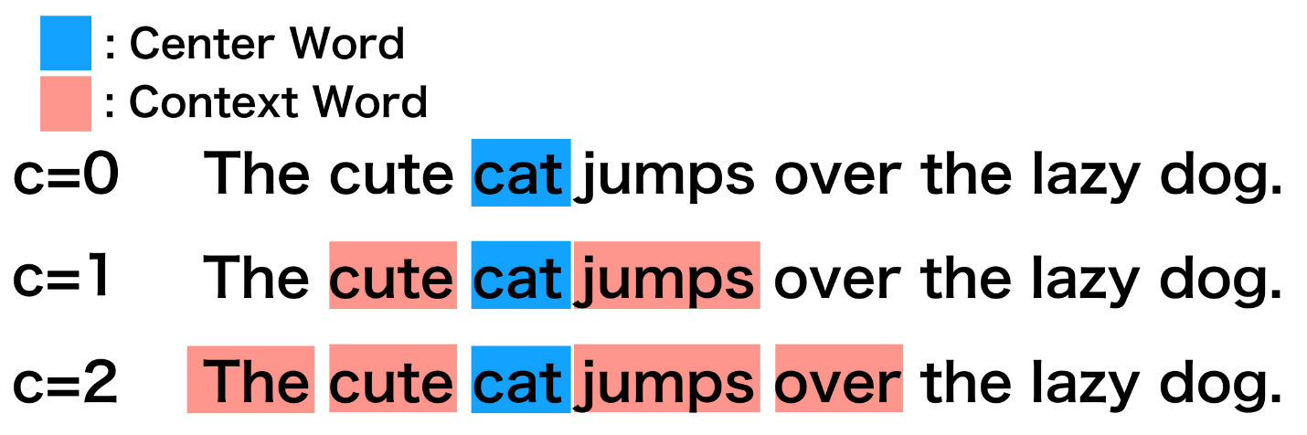

Figure 26

When c=2 → 2c+1=2*2+1 → window size=5

Then sliding window on each word and make these calculates to include the full sentences and predict miss words

**One-hot vector**

**Transforming center words into vectors by calculate average of individual one-hot-vector**

This transformation is important due to the fact many system mastering algorithms(along with deep nets) require their enter to be vectors of nonstop values; they simply work on strings of plain text.

suppose the corpus is “i am happy because i am learning” and the inputs are “I am because I”

0→ if the input not found in corpus

1→ if the input found in corpus

add each vector in each column with the next vector then divide by numbers of vectors that are created.

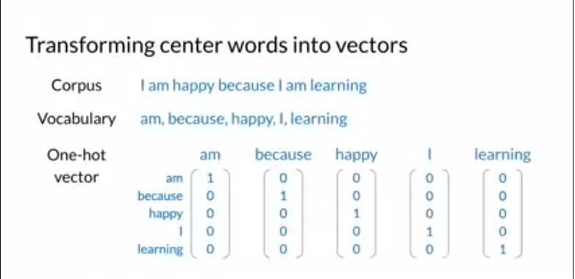

Figure 27

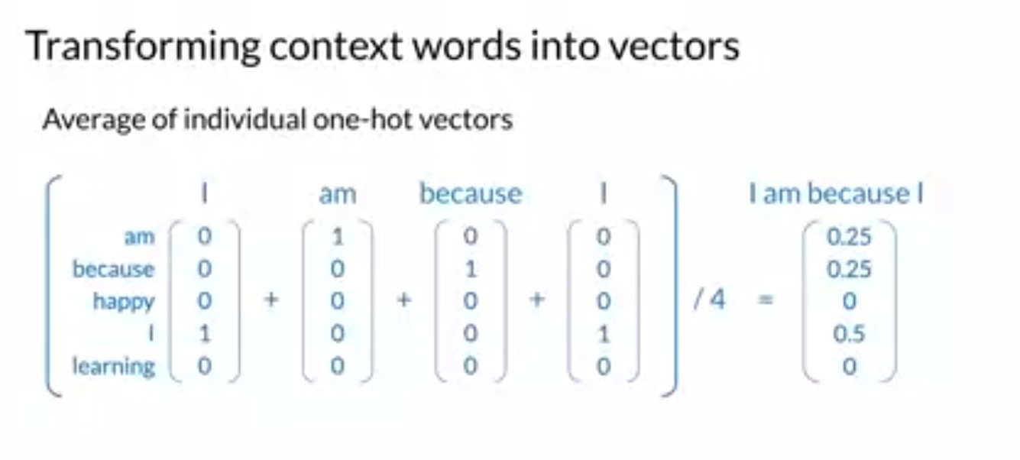

Figure 28

The number of vectors is 4.

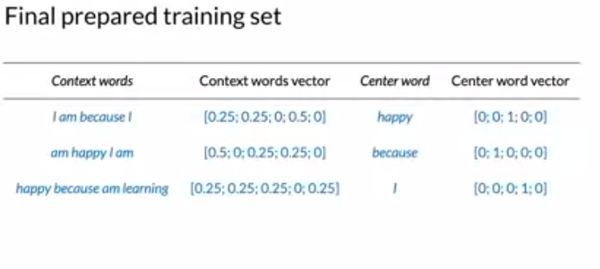

Figure 29

The generated context word (input) is represented as vector [0.25 0.25 0 0.5 0], then this vector is compared with the original corpus. if the word found it is given a weight equal to 0.

if not, fount then it is given a weight equal to 1, such as happy. so, it will be the centered word represented as output(happy)

**Back End**

The backend of the Chatbot website consists of the following technologies: Java, Spring and Maven. each described below to give you a better understanding of the architecture of our software.

**Java**

Why java?

The first and most important reason is that the team was most familiar with Java, so we chose it. Java is also highly scalable. Java EE can cluster instances in a transparent way. Also, multiple instances can serve requests. This was a must in our use case, as we needed to serve more than one client at a time.

**Spring framework**

The Spring Framework is an application framework and control inversion container for the Java platform. The core features of the framework can be used by any Java application.[99]

Spring is currently ubiquitous, being adapted by companies and enjoying increasing popularity among developers. It is also flexible. With Spring's flexible and comprehensive extensions and third-party libraries, developers can create almost any application imaginable. Performance also plays an important role in Spring, as it focuses on fast start ups and shutdowns.[11]

**IntelliJ Ultimate**

IntelliJ Ultimate was our editor of choice. It’s easy to use, handy navigation and we had an easy time collaborating through it. It has support for Git so version control was easy to manage.

**Maven**

Maven is a build automation tool used primarily for Java projects. By adding dependencies we were able to add all libraries that our project needed through our POM (Project Object Model ) file. All dependencies relevant are listed below.

**Ajax**

Ajax is used in the JavaScript file in our project to create a asynchronous web application.

**Dependencies in the POM file**

* spring
* spring-boot-starter-web
  + Starter for building web, including RESTful, applications using Spring MVC. Uses Tomcat as the default embedded container.
* tomcat-embed-jasper
  + An embedded Tomcat server consists of a single Java web application together with a full Tomcat server distribution packaged together and compressed into a single file JAR, WAR or ZIP.
* spring-boot-starter-webflux
  + Starter for building WebFlux applications using Spring Framework's Reactive Web support.
* com.theokanning.openai-gpt3-java
  + Java libraries for using OpenAI's GPT-3 api.
* org.apache.poi
  + provides pure Java libraries for reading and writing files in Microsoft Office formats, such as Word, PowerPoint and Excel.

com.google.code.gson

* + Gson is a Java library that can be used to convert Java Objects into their JSON re
  + presentation.

**UML of the project**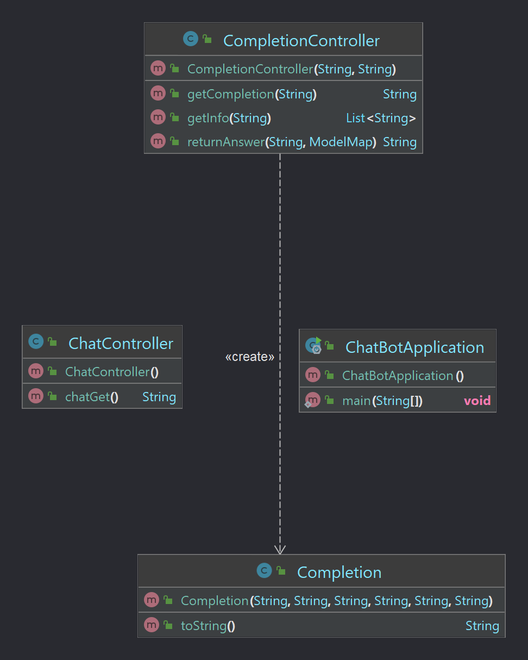

Figure 30

ChatBotApplication

Main class of our application. It is responsible for integrating our main class into the Spring framework by collecting all classes in the project.

ChatController

Responsible for returning the required HTML page when a client/user interacts with the website.

CompletionController

Responsible for using the OPENAI model, which we have optimized to produce a financial statement, and for reading Excel files describing how to protect yourself against the list of diseases we have trained our model to detect.

Completion

A class that consists of our completion, just a representation of data to display to the user.

The flow of the application is shown in figure 31.

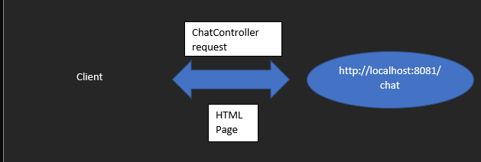

Figure 31

After the client receives the html page, he sends his symptoms by writing text and clicking send. Figure 31.

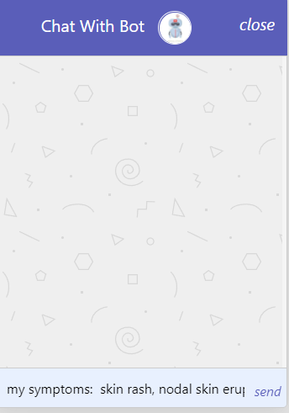

Figure 32

Then the user input is sent to the server and received by our AJAX snippet in the HTML page. AJAX then sends a request to the completion controller to get a completion and sends it to the user. More about the implementation later. Figure 32 describes the process.

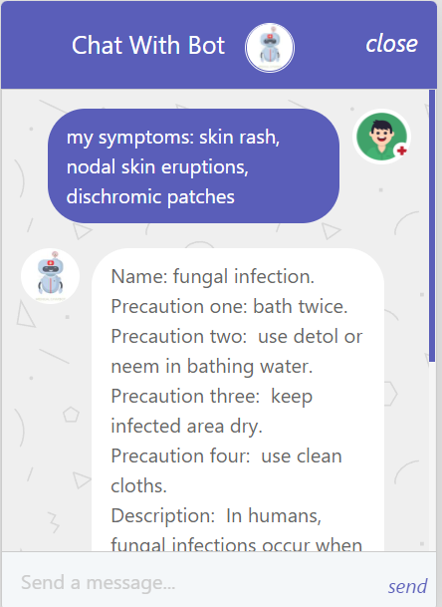

Figure 33

## Front-end

The front end of the website consists of the following technologies: HTML, CSS, Javascript, and Bootstrap.

Clearly, the design of the chatbot was not our focus in this stage, however we tried to make a design that every user can easily interact with.

# **Software implementation**

We have done our best to implement the code according to clean code principles, no coding smells whatsoever. Also with low coupling and high cohesion, we were able to make the code so that it can be reused in the future if the project is to continue.

**Open Ai**

First, We must download OpenAi Api by using command prompt (pip install —upgrade openai)

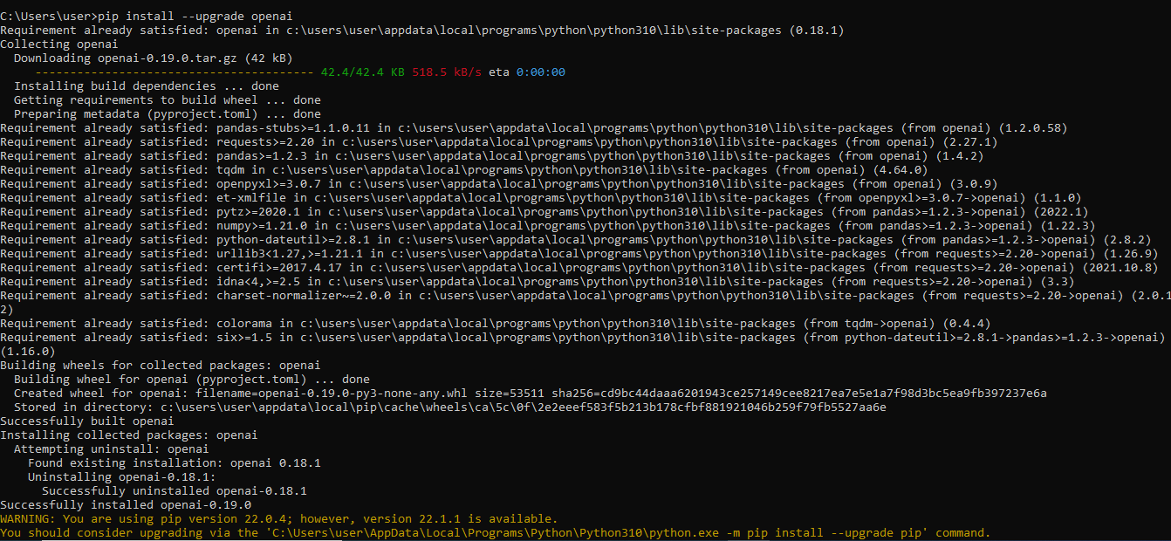

Figure 34

Second, Add OPEN_AI_KEY in system environment

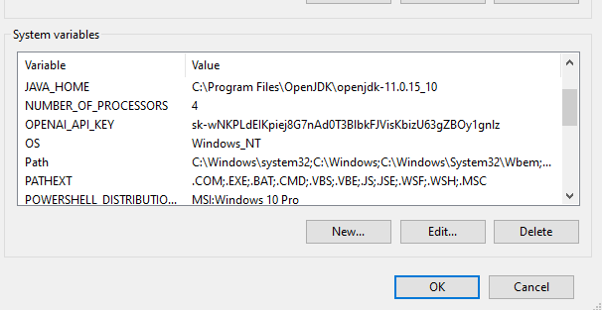

Figure 35

Third, the data training must be in JSONL format, such as:

{"prompt": "<prompt text>", "completion": "<ideal generated text>"}

We use the python to convert the data in dataset from csv to JSONL by making these steps:

* Read Data from CSV file
* 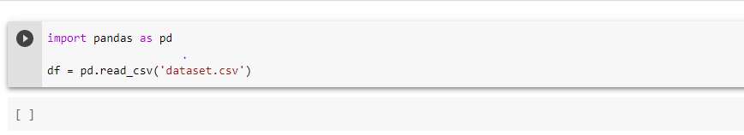

Figure 36

The data in Data Set like this:

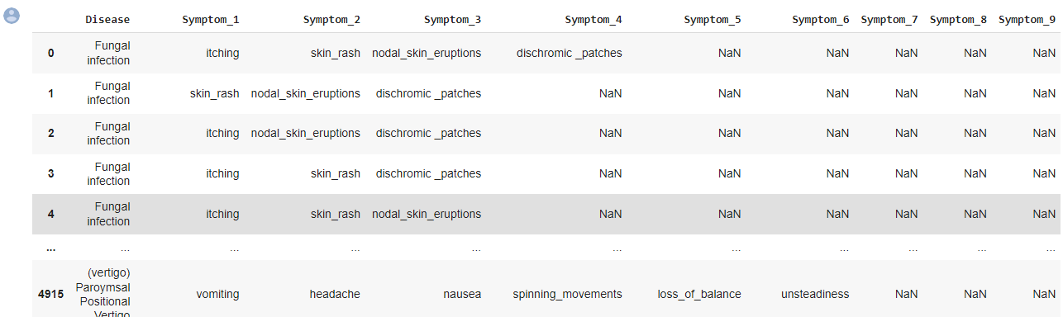

Figure 37

Then, we add ‘’I have’’ in symptoms

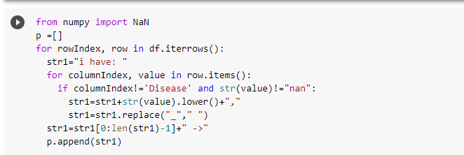

Figure 38

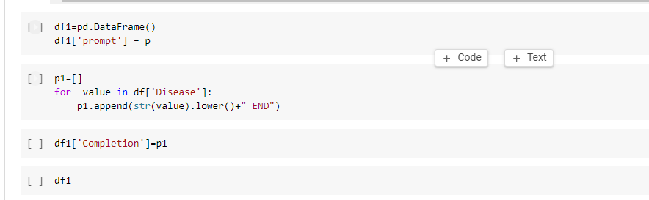

Figure 39

The result like prompt and completion like this:

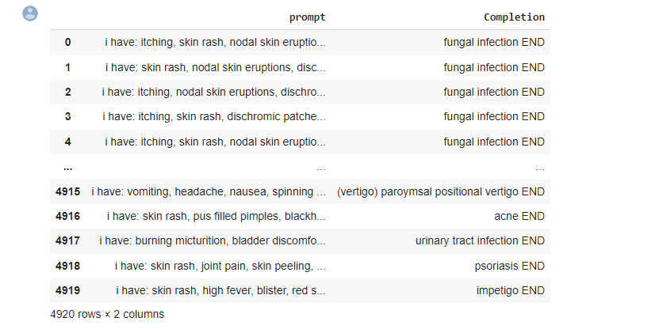

Figure 40

Then this command is used.

openai tools fine_tunes.prepare_data -f <csv file name>

to convert csv file to JSONL like this:

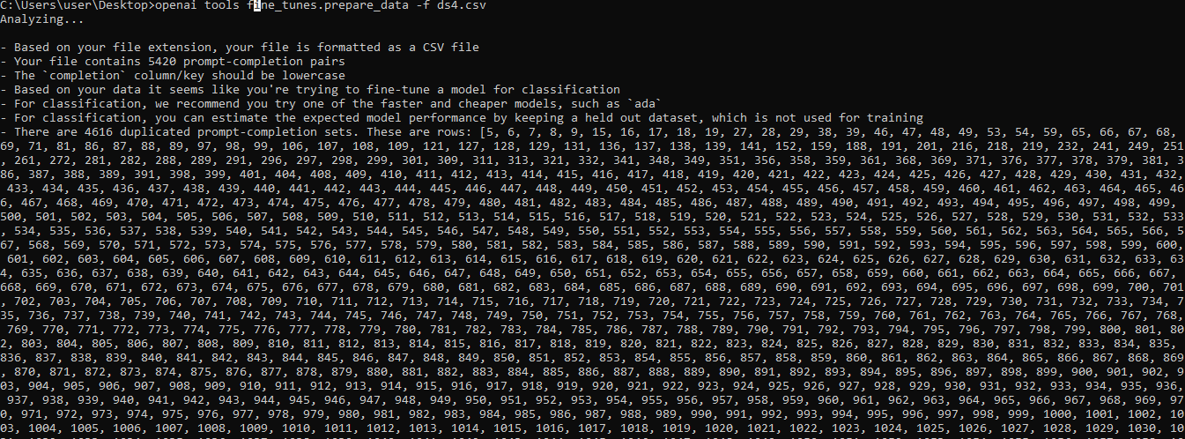

Figure 41

then the data must be split in two sides (training and validation data):

We enter Y for yes because the dataset must be divided into two parts, training and validation datasets.

Training dataset: A set of samples used for learning, that's to fit the parameters of the classifier (as symptoms of disease in our dataset).

Validation dataset: A set of cases used to tune the parameters of a classifier, for illustration to choose the number of hidden units in a neural network.

Generally, “validation set” is used interchangeably with the term “ test set ” and refers to a sample of the dataset held back from training the model.

The evaluation of a model skill on the training dataset would affect in a partial score. thus, the model is estimated on the held- out sample to give a fair estimate of model skill. This is generally called a train- test split approach to algorithm evaluation. Suppose that we'd like to estimate the test error associated with fitting a particular statistical learning way on a set of compliance. The validation set approach (…) is a veritably simple strategy for this task. It involves randomly dividing the available set of compliance into two parts, a training set and a validation set or hold- out set. The model is fit on the training set, and the fitted model is used to prognosticate the responses for the compliances in the validation set. The performing validation set error rate provides an estimate of the test error rate.

the final model evaluation must be performed on a held-out dataset that has not been used previous, either for training the model or tuning the model parameters.

– Test set: A dataset of samples used only to assess the performance of a completely- specified classifier.

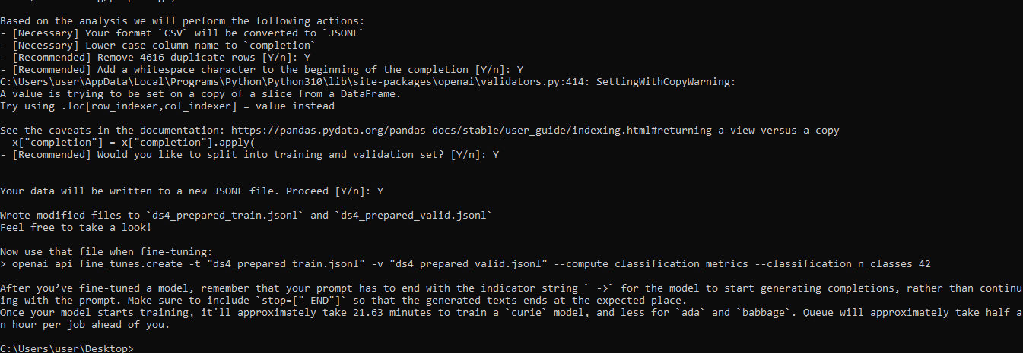

Figure 42

Finally, training the data and the openai give us the engine name to use it in my code:

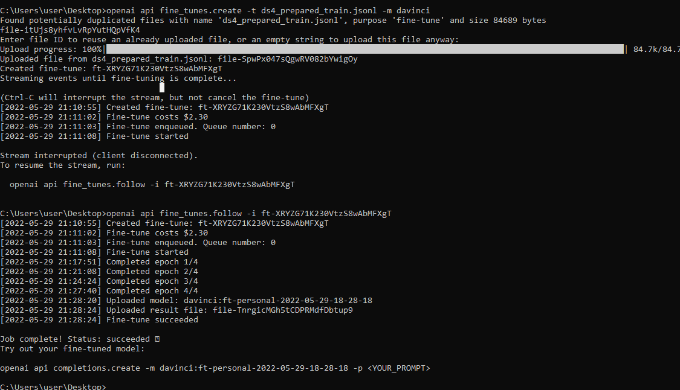

Figure 43

Back-End Implementation

We have done our best to implement the code according to clean code principles, no coding smells whatsoever. Also, with low coupling and high cohesion, we were able to make the code so that it can be reused in the future if the project is to continue.

After running the application, spring loads all the dependencies. These dependencies are then injected into the project. the dependencies are mentioned above. Figure (44) shows the program loading these dependencies.

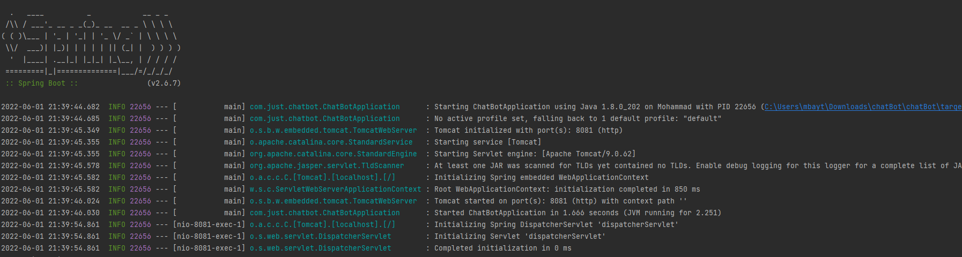

Figure 44

As shown in figure 44, the application is running on [localhost:8081](http://localhost:8081/). ChatController is listening on [localhost:8081/chat](http://localhost:8081/chat) for any Get requests, if any are made, the String “chat” which leads to the chat JSP is returned to the client. and page in figure 1.6 is shown.

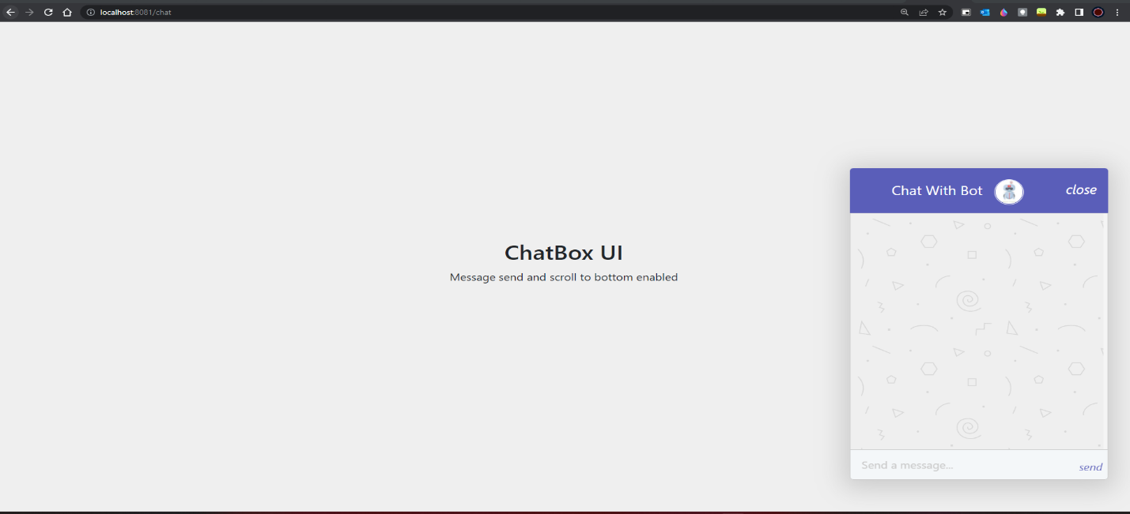

Figure 45

As figure 45 shows, the HTML page is sent to users and waits for them to enter their symptoms.

When the user clicks Send after entering the symptoms, the symptoms are sent to the server.

After the data is received on the server, a Get request is sent to the CompletionController.

CompletionController assigns our OpenAI key and the OpenAI engine via Spring Auto-Wiring. The values can be wired automatically as they are defined in our application properties.



Figure 46

The Spring framework enables automatic dependency injection. In other words: If you declare all bean dependencies in a Spring configuration file, the Spring container can automatically establish the relationships between cooperating beans. This is called Spring bean autowiring. Beans are not classes, but objects for the entire project.

The CompletionController processes the user input, adds the required stop sequence and adds '→' to the prompt so that the AI engine gets better results.

Each input should end with a fixed separator to inform the model when the prompt ends and the completion begins. our operator of choice and the recommended one was ‘->’

The controller also opens and reads the Excel files we provide, which contain all the disease names and precautions in our dataset.

Completion is then generated by a query to our fine-tuned openAI model, and a completion is generated. Then the disease definition and precautions are added to the completion.

The completion is then returned as a string in JSON format in the get request to the HTML page.

Using AJAX, the completion is provided to the user asynchronously without refreshing the page.

**VI.** **Bibliography**

[1] <https://beta.openai.com/docs/api-reference/introduction#completions/\>

[2] https://beta.openai.com/docs/engines/overview

[3]<https://hackernoon.com/a-brief-intro-to-the-gpt-3-algorithm-t31f37k5>

[4] <https://jalammar.github.io/illustrated-transformer/>

[5] <https://medium.com/nerd-for-tech/how-gpt-3-actually-works-from-the-ground-up-5714ae7f3355>

[5][https://www.techtarget.com/searchenterpriseai/feature/Exploring-GPT-3-architecture](https://www.techtarget.com/searchenterpriseai/feature/Exploring-GPT-3-architecture%20)

[6] Attention Is All You Need, [Ashish Vaswani](https://arxiv.org/search/cs?searchtype=author&query=Vaswani%2C+A), [Noam Shazeer](https://arxiv.org/search/cs?searchtype=author&query=Shazeer%2C+N), [Niki Parmar](https://arxiv.org/search/cs?searchtype=author&query=Parmar%2C+N), [Jakob Uszkoreit](https://arxiv.org/search/cs?searchtype=author&query=Uszkoreit%2C+J), [Llion Jones](https://arxiv.org/search/cs?searchtype=author&query=Jones%2C+L), [Aidan N. Gomez](https://arxiv.org/search/cs?searchtype=author&query=Gomez%2C+A+N), [Lukasz Kaiser](https://arxiv.org/search/cs?searchtype=author&query=Kaiser%2C+L), [Illia Polosukhin](https://arxiv.org/search/cs?searchtype=author&query=Polosukhin%2C+I) <https://arxiv.org/abs/1706.03762>

[7]<https://medium.com/deeper-learning/glossary-of-deep-learning-word-embedding-f90c3cec34ca>

[8]<https://blog.acolyer.org/2016/04/21/the-amazing-power-of-word-vectors/>

[9] <https://ronxin.github.io/wevi/>

[10]<https://www.coursera.org/lecture/probabilistic-models-in-nlp/transforming-words-into-vectors-gCkdx>

[11][https://en.wikipedia.org/wiki/Spring_ Framework](https://en.wikipedia.org/wiki/Spring_%09Framework)